Micro-Lance

Milia are visible, hard, white plugs of sebum that lie very close to the skin’s surface. A client may have a single milia or many. They do not burst or ooze pus as a spot may, and, with careful technique, can be extracted without bleeding or scarring and shown to the client.

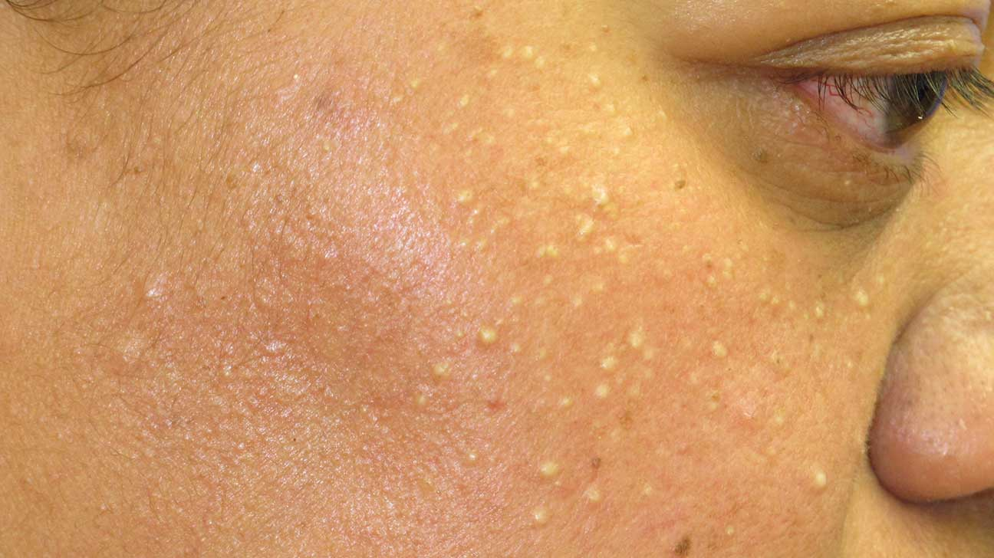

A micro-lance is a sharp-edged sterile disposable probe for piercing skin to remove foreign objects. It can be used to remove splinters and ingrowing hair as well as extracting milia.

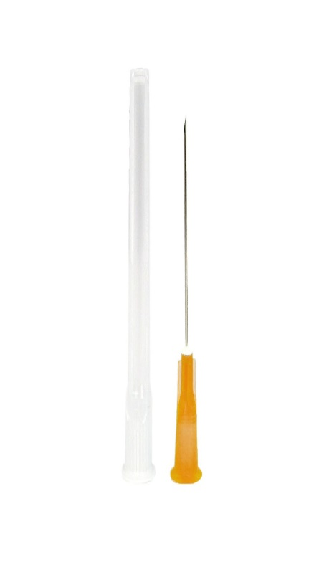

The area around the milia must be thoroughly checked and cannot be treated if the skin is infected or if the milia is near the eyes. The skin must be thoroughly cleansed with a suitable product and a scaling fluid applied to the area. Gloves must be worn and the micro-lance needs to be kept in the sterile packaging until needed and opened/disposed of in front of the client. After removing the probe, the skin should be pulled taught and broken with the lance on one side of the milia, only going as deep as the bottom edge of the milia. The gloved therapist should wrap tissues over their fingers and the milia wiggled out with gentle but firm pressure. After extraction, the area should be moisturised with a rehydrating gel or lotion, or similar appropriate product.

Needles MUST be disposed of in a yellow sharps box and taken away and disposed of by a licensed company as clinical waste. The client must be extra careful with the area around the extraction and should be encouraged not to pick at any scab that might form.